Implementation: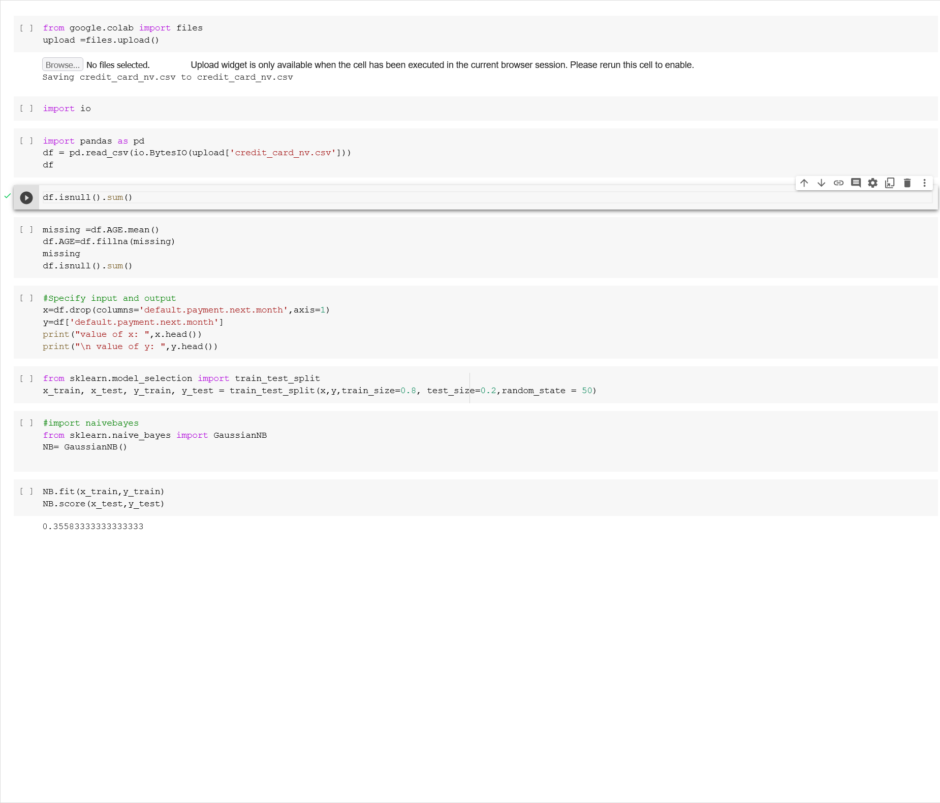

Conclusion:

Implementation:

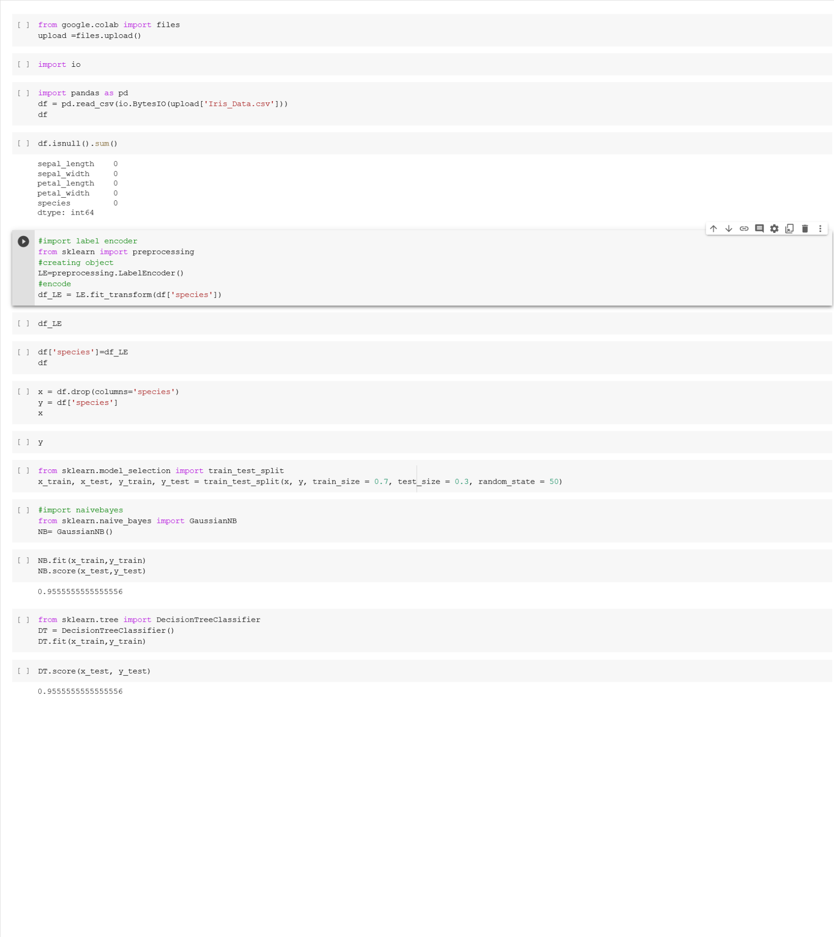

Conclusion:

Implementation:

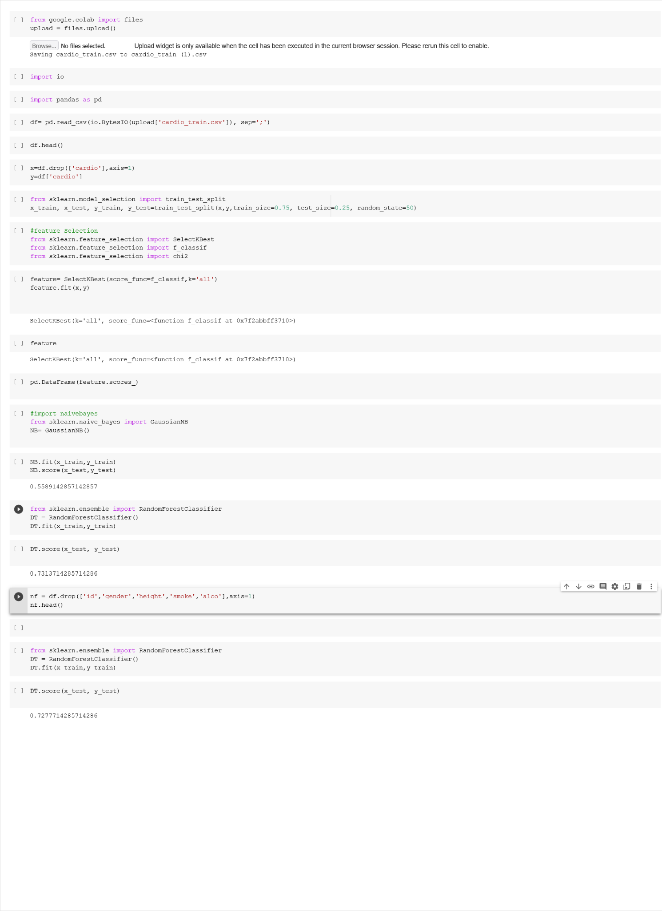

Conclusion:

Implementation:

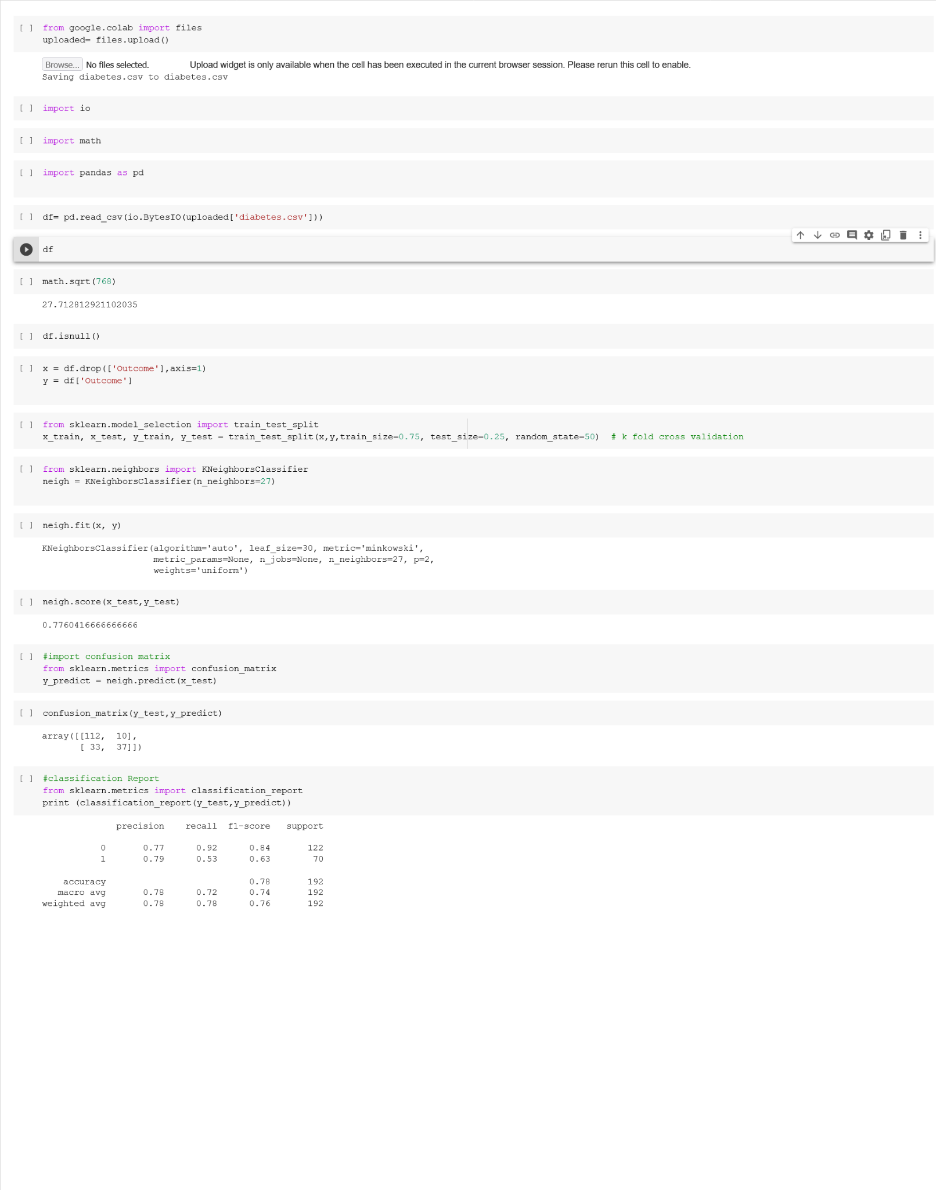

Conclusion:

Port City International University



Course Title: Pattern Recognition

Course Code: CSE 331

Assignment No: 1

Assignment Name

K-th Nearest Neighbor algorithm

Submitted to

Sabbir Al Ahsan

Lecturer, Dept. of Computer Science and Engineering

Submitted by

Md. Istiak Sharif

Batch: 17th (Day)

ID NO: CSE 01706571

Date: 22/10/2021

Port City International University



Course Title: Pattern Recognition Sessional

Course Code: CSE 332

Report No: 1

Report Name

Naive Bayes, DT, RF, KNN algorithm Implementation

Submitted to

Sabbir Al Ahsan

Lecturer, Dept. of Computer Science and Engineering

Submitted by

Md. Istiak Sharif

Batch: 17th (Day)

ID NO: CSE 01706571

Date: 22/10/2021